IMMC 2021 1st Mini-Project—Rating System to Rate the Math Level of Students
Team: Justin, Ryan, Joyce, Letitia

- Assumptions and Justifications

Assumption 1: The students who would be chosen to be rated through the rating system are all in math H level.
Justification: This factor can make the diagram easier to understand because the students who will be rated are all on the same level, therefore lessening the variables that need to be considered.

Assumption 2: The students who are chosen to be rated have all only participated in one test between AMC 8 and AMC 10.
Justification: With this factor, the produced rating system can be simpler and easier to navigate. Furthermore, it will serve to make the system fair and not incline towards the students who have participated in two or more AMC tests.

Assumption 3: The number of midterms and finals taken by the math H-level students are both 2.
Justification: This will ensure that the final result will not be impacted by the varying number of tests that different students might have taken. Since the final score will be higher with the more tests’ scores that it will add onto, limiting the number of tests that the students has taken is will also make the system fairer.

- Variables

Variable name | Definition
S₁ | The score out of 25 points for AMC 8
S₂ | The score out of 150 points for AMC 10
p | The performance of math in-school (constists of [] and [])
m | The score of out of 100 math midterm test
f | The score of out of 100 math final test

- Math Level Rating System

Rating System to Determine Different H-level students’ Math Level
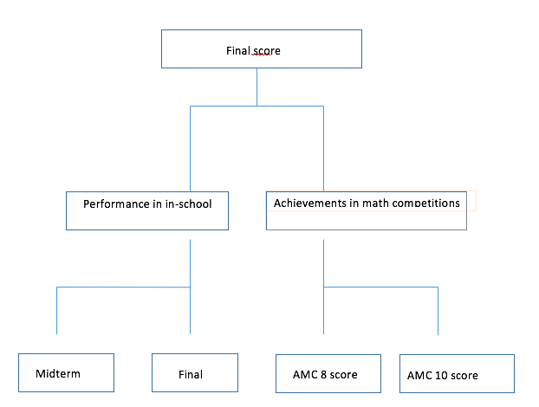

- Strengths

- With this rating system, we can be able to calculate and compare the final results by the means of rating system in a systematical and fair way through adding the scores with equivalent total points and also by considering factors and scores of the student both in and outside of class.

- Weaknesses

- Some students may have little to none competition experience that might affect their competition scores that is not mathematic.

